Hands on session
PLSQL Excerises

Exercise 3: Stored Procedures
Scenario 1: The bank needs to process monthly interest for all savings accounts.
  - Question: Write a stored procedure ProcessMonthlyInterest that calculates and updates the balance of all savings accounts by applying an interest rate of 1% to the current balance.

Scenario 2: The bank wants to implement a bonus scheme for employees based on their performance.
  - Question: Write a stored procedure UpdateEmployeeBonus that updates the salary of employees in a given department by adding a bonus percentage passed as a parameter.

Scenario 3: Customers should be able to transfer funds between their accounts.
  - Question: Write a stored procedure TransferFunds that transfers a specified amount from one account to another, checking that the source account has sufficient balance before making the transfer.
Objective
Modularize logic using stored procedures for reusability and separation of business rules.
Steps to implement
- Step 1: Create Tables
- savings_accounts: For interest calculation
- employees: For salary bonus updates
- accounts: For fund transfer between accounts
- Step 2: Insert Sample Data
- Add multiple records into each table for realistic testing.
- Step 3: Scenario 1 – Monthly Interest on Savings Accounts
- Use ProcessMonthlyInterest
- Step 4: Scenario 2 – Bonus for Employees
- Use UpdateEmployeeBonus(p_department_id, p_bonus_percent)
- Scenario 3 – Transfer Funds Between Accounts
- Use TransferFunds(p_from_account, p_to_account, p_amount)
- Step 6: Call Each Procedure

Code
SET SERVEROUTPUT ON;

BEGIN EXECUTE IMMEDIATE 'DROP TABLE savings_accounts'; EXCEPTION WHEN OTHERS THEN NULL; END;

-- Step 1: Create Tables

-- Table: Savings Accounts
CREATE TABLE savings_accounts (
account_id NUMBER PRIMARY KEY,
customer_id NUMBER,
balance NUMBER
);

-- Table: Employees
CREATE TABLE employees (
emp_id NUMBER PRIMARY KEY,
emp_name VARCHAR2(100),
salary NUMBER,
department_id NUMBER
);

-- Table: Accounts (for fund transfer)
CREATE TABLE accounts (
account_id NUMBER PRIMARY KEY,
customer_id NUMBER,
balance NUMBER
);

-- Step 2: Insert Sample Data

-- Savings Accounts
INSERT INTO savings_accounts VALUES (1, 101, 1000);
INSERT INTO savings_accounts VALUES (2, 102, 5000);
INSERT INTO savings_accounts VALUES (3, 103, 7500);

-- Employees
INSERT INTO employees VALUES (1, 'Alice', 30000, 10);
INSERT INTO employees VALUES (2, 'Bob', 35000, 10);
INSERT INTO employees VALUES (3, 'Charlie', 40000, 20);

-- Accounts
INSERT INTO accounts VALUES (101, 201, 10000);
INSERT INTO accounts VALUES (102, 202, 2000);

COMMIT;

-- Step 3: Stored Procedure - ProcessMonthlyInterest
CREATE OR REPLACE PROCEDURE ProcessMonthlyInterest IS
BEGIN
FOR acc IN (
SELECT account_id, balance FROM savings_accounts
) LOOP
UPDATE savings_accounts
SET balance = balance + (balance * 0.01)
WHERE account_id = acc.account_id;
END LOOP;
COMMIT;
END;
/

-- Call procedure
BEGIN
ProcessMonthlyInterest;
DBMS_OUTPUT.PUT_LINE('✅ Monthly interest applied.');
END;
/

-- View updated savings accounts
SELECT * FROM savings_accounts;

-- Step 4: Stored Procedure - UpdateEmployeeBonus
CREATE OR REPLACE PROCEDURE UpdateEmployeeBonus(
p_department_id IN NUMBER,
p_bonus_percent IN NUMBER
) IS
BEGIN
UPDATE employees
SET salary = salary + (salary * (p_bonus_percent / 100))
WHERE department_id = p_department_id;
COMMIT;
END;
/

-- Call procedure (e.g., 10% bonus to department 10)
BEGIN
UpdateEmployeeBonus(10, 10);
DBMS_OUTPUT.PUT_LINE('✅ Bonus updated for department 10.');
END;
/

-- View updated employee salaries
SELECT * FROM employees;
-- Step 5: Stored Procedure - TransferFunds

CREATE OR REPLACE PROCEDURE TransferFunds(
p_from_account IN NUMBER,
p_to_account IN NUMBER,
p_amount IN NUMBER
) IS
v_balance NUMBER;
BEGIN
-- Get source balance
SELECT balance INTO v_balance
FROM accounts
WHERE account_id = p_from_account;

IF v_balance >= p_amount THEN
UPDATE accounts
SET balance = balance - p_amount
WHERE account_id = p_from_account;

UPDATE accounts
SET balance = balance + p_amount
WHERE account_id = p_to_account;

COMMIT;
DBMS_OUTPUT.PUT_LINE('✅ Transfer successful.');
ELSE
RAISE_APPLICATION_ERROR(-20001, '❌ Insufficient balance in source account.');
END IF;
END;
/

-- Call procedure (valid transfer)
BEGIN
TransferFunds(101, 102, 3000);
END;
/

-- Check balances
SELECT * FROM accounts;

-- Call procedure (invalid transfer, should fail)
BEGIN
TransferFunds(102, 101, 10000);
END;
/

-- Final Output Message
SELECT '✅ Exercise 3: All procedures executed successfully!' AS status FROM dual;

Output

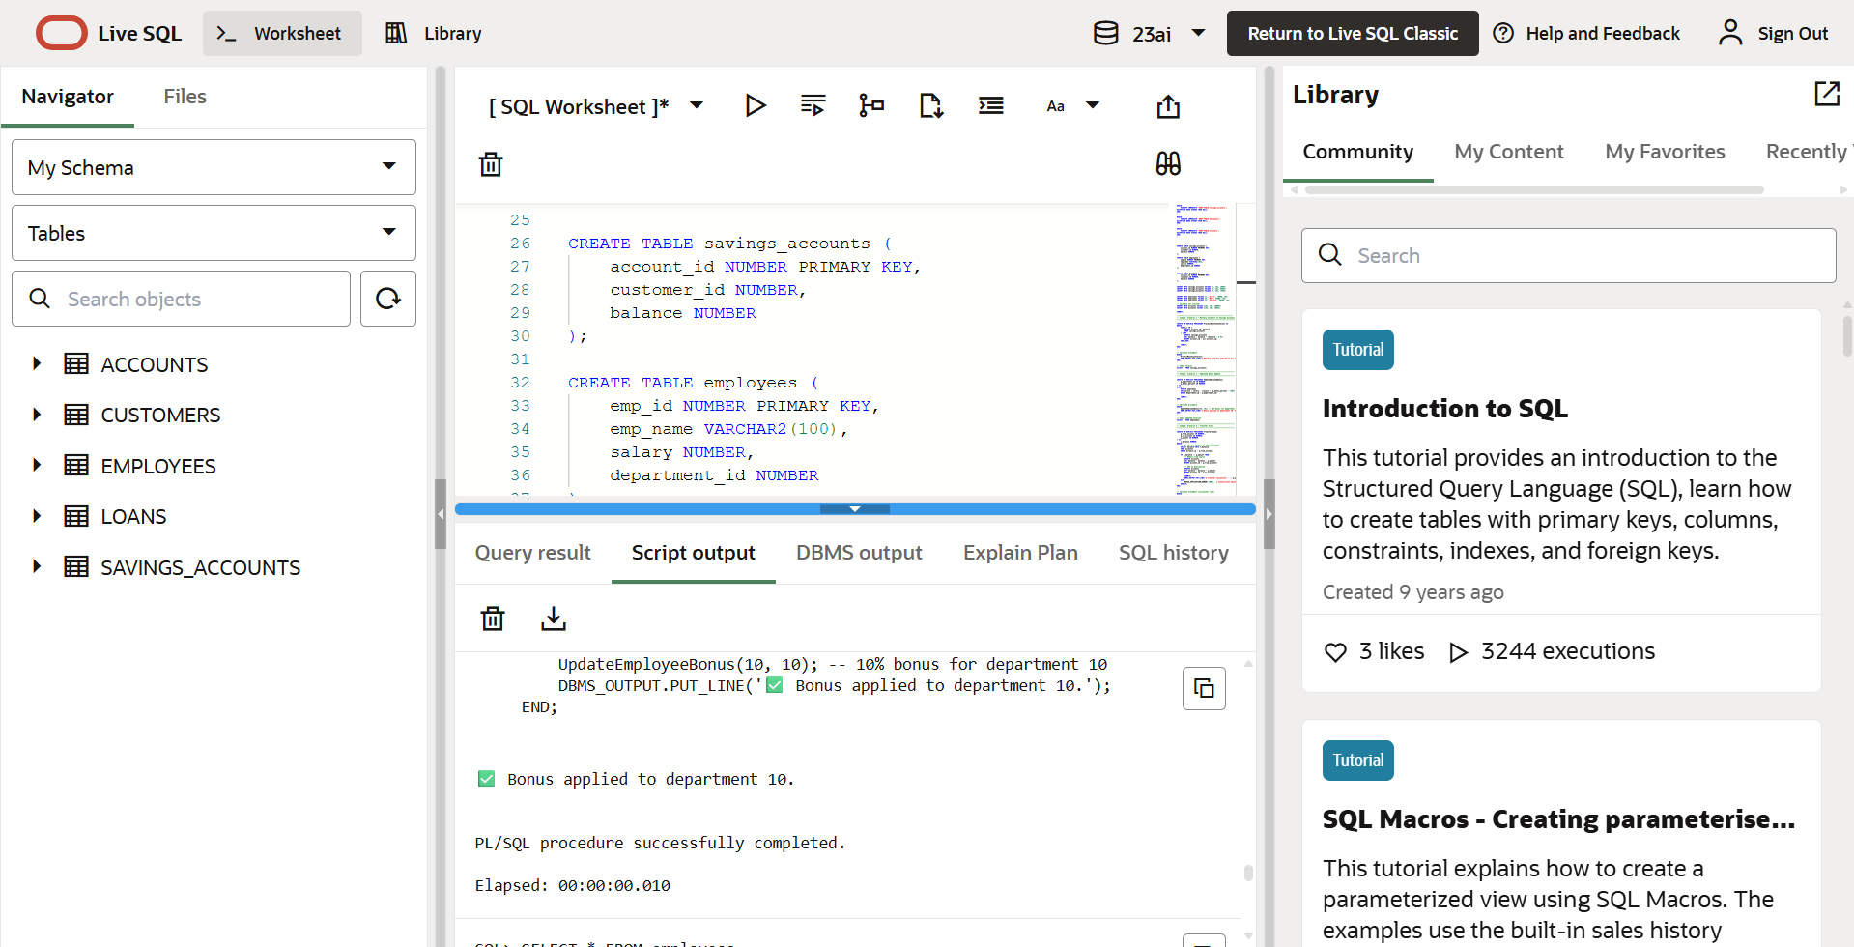

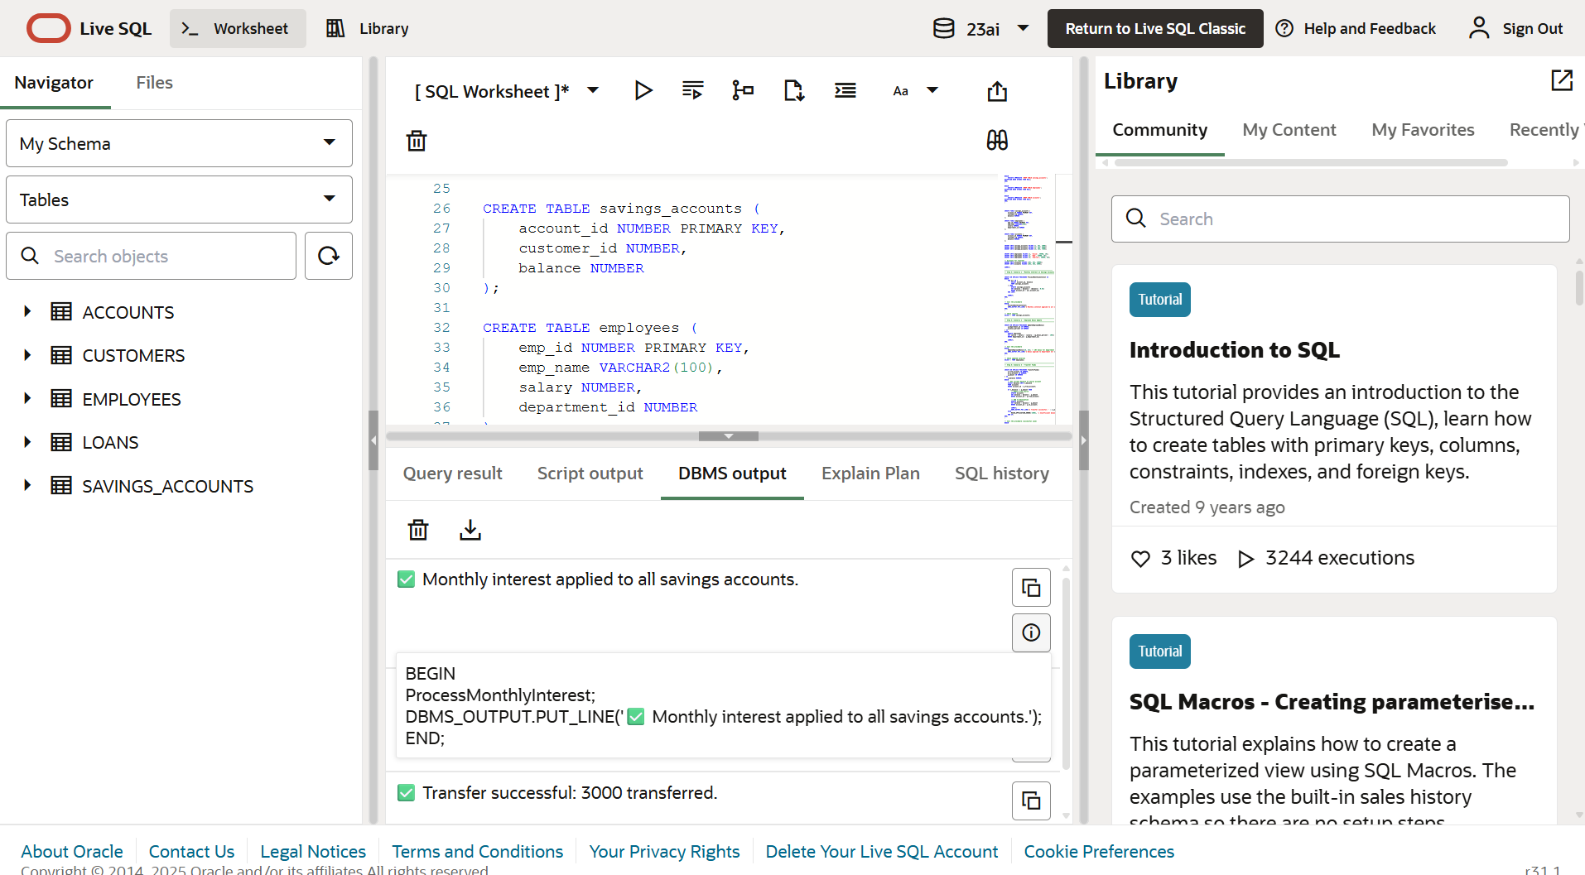
DBMS Output

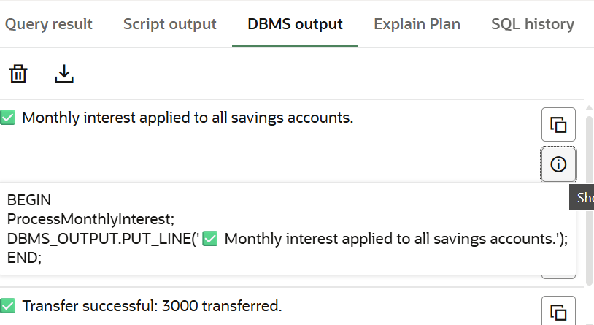
Scenario 1

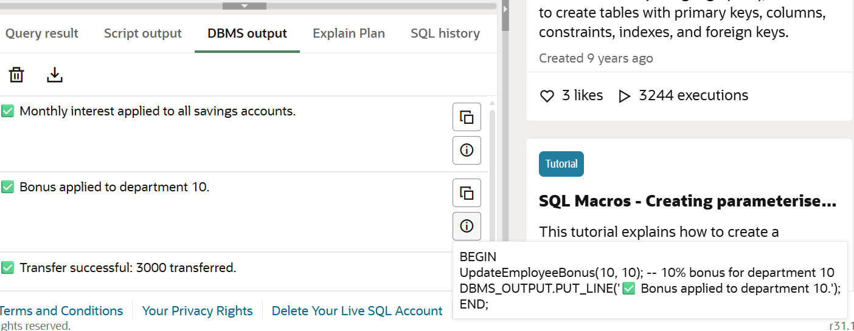
Scenario 2

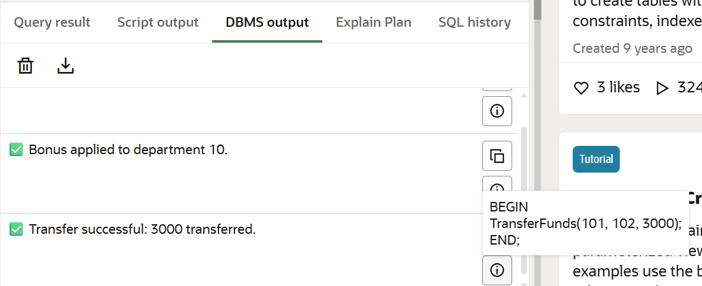
Scenario 3

